Semester One Examination, 2016

Question/Answer Booklet

MATHEMATICS

SOLUTIONS
METHODS
UNIT 1

Section Two:

Calculator-assumed

Student Number: In figures

In words

Your name

Time allowed for this section
Reading time before commencing work: ten minutes
Working time for section: one hundred minutes

Materials required/recommended for this section
To be provided by the supervisor
This Question/Answer Booklet
Formula Sheet (retained from Section One)

To be provided by the candidate
Standard items: pens (blue/black preferred), pencils (including coloured), sharpener, correction fluid/tape, eraser, ruler, highlighters

Special items: drawing instruments, templates, notes on two unfolded sheets of A4 paper, and up to three calculators approved for use in the WACE examinations

Important note to candidates
No other items may be taken into the examination room. It is your responsibility to ensure that you do not have any unauthorised notes or other items of a non-personal nature in the examination room. If you have any unauthorised material with you, hand it to the supervisor before reading any further.

Structure of this paper

Section | Number of questions available | Number of questions to be answered | Working  time (minutes) | Marks available | Percentage of exam
Section One:  Calculator-free | 7 | 7 | 50 | 50 | 35
Section Two:  Calculator-assumed | 13 | 13 | 100 | 99 | 65
 |  |  | Total | 149 | 100

Instructions to candidates

- The rules for the conduct of examinations are detailed in the school handbook. Sitting this examination implies that you agree to abide by these rules.

- Write your answers in this Question/Answer Booklet.

- You must be careful to confine your response to the specific question asked and to follow any instructions that are specified to a particular question.

- Spare pages are included at the end of this booklet. They can be used for planning your responses and/or as additional space if required to continue an answer.
- Planning: If you use the spare pages for planning, indicate this clearly at the top of the page.
- Continuing an answer: If you need to use the space to continue an answer, indicate in the original answer space where the answer is continued, i.e. give the page number. Fill in the number of the question that you are continuing to answer at the top of the page.

- Show all your working clearly. Your working should be in sufficient detail to allow your answers to be checked readily and for marks to be awarded for reasoning. Incorrect answers given without supporting reasoning cannot be allocated any marks. For any question or part question worth more than two marks, valid working or justification is required to receive full marks. If you repeat any question, ensure that you cancel the answer you do not wish to have marked.

- It is recommended that you do not use pencil, except in diagrams.

- The Formula Sheet is not to be handed in with your Question/Answer Booklet.

Section Two: Calculator-assumed 65% (99 Marks)
This section has thirteen (13) questions. Answer all questions. Write your answers in the spaces provided.

Working time for this section is 100 minutes.

Question 8 (6 marks)
The results from a clinical study on the effect of sleep on reaction times for a group of 210 male police cadets is shown in the table below. The participants were given either 4, 6 or 8 hours' sleep, woken and immediately asked to perform a series of tasks involving reacting to various stimuli, from which the total reaction time was calculated.

 | Total reaction time less than 3 s | Total reaction time 3 s or more.
Tested after 4 h sleep | 18 | 55
Tested after 6 h sleep | 21 | 49
Tested after 8 h sleep | 22 | 45

(a) Determine the probability that a randomly chosen participant

(i) had a total reaction time of less than 3 s. (1 mark)
Solution
Specific behaviours
determines probability

(ii) was tested after 8 h sleep and had a total reaction time 3 s or more. (1 mark)
Solution
Specific behaviours
determines probability

(b) Determine the probability that a randomly chosen participant had a reaction time of less than 3 s given they were woken after

(i) 4 h sleep. (1 mark)
Solution
Specific behaviours
determines probability

(ii) 8 h sleep. (1 mark)
Solution
Specific behaviours
determines probability

(c) Does the study suggest that reaction time is independent of sleep? Explain your answer.
(2 marks)
Solution
No - the probability of a faster reaction time changed from 0.25 to 0.33 as length of sleep increased, suggesting that not independent.
Specific behaviours
states no
supplies reason based on answers to (b)

Question 9 (7 marks)
The graphs of the functions, and are shown below, where a, b, c, d, m and n are positive constants.

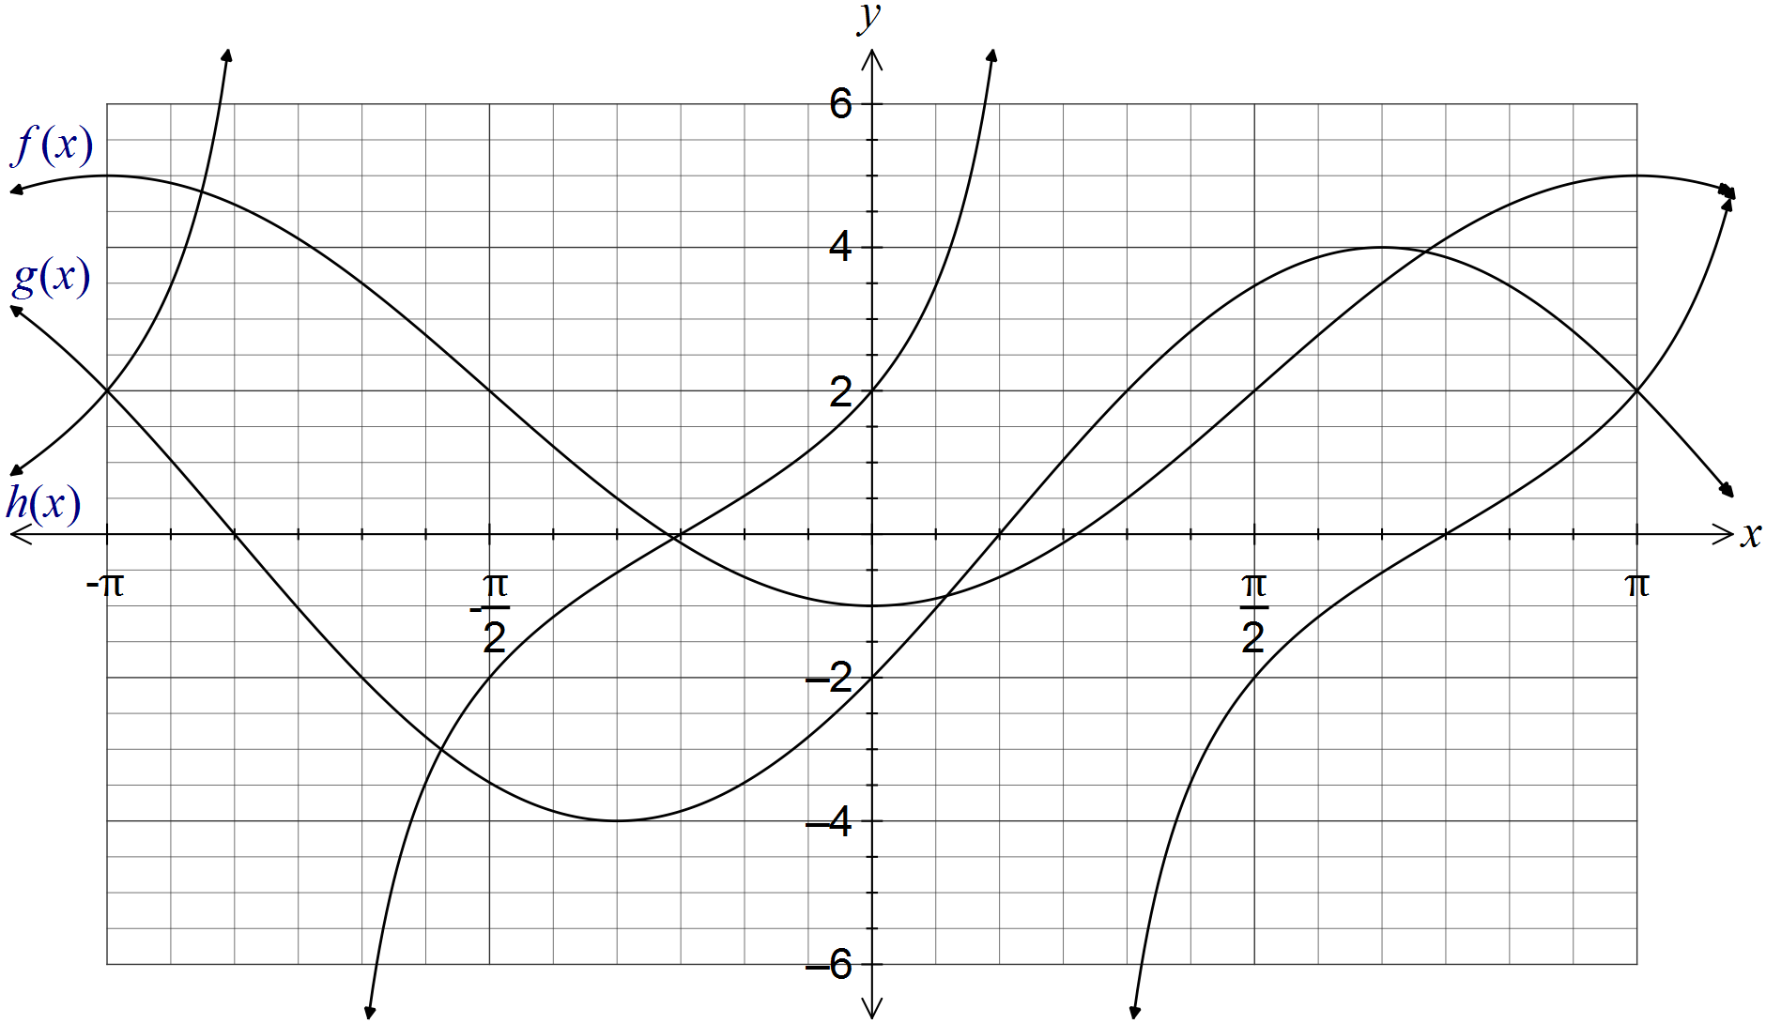

(a) Clearly label each of the functions f, g and h on the graph. (1 mark)

(b) Determine the values of the positive constants a, b, c, d, m and n. (6 marks)
Solution
Cos function has max value of 5, min of -1 and starts at min. .

Sin function has amplitude of 4 and first root at . .
(Strictly, )

Tan function: Root at , and midway between root and asymptote, .
(Strictly, )
Specific behaviours
award one mark per value

Question 10 (7 marks)
When a box of three fragile glasses is sent through the post, the probability that none of the glasses break is $\frac{1}{2}$, that one breaks is $\frac{7}{20}$ and that two break is $\frac{3}{25}$.

(a) Determine the probability that

(i) at least one glass breaks. (1 mark)
Solution
Specific behaviours
obtains correct probability

(ii) fewer than two glasses break. (1 mark)
Solution
Specific behaviours
obtains correct probability

(iii) exactly three glasses break. (1 mark)
Solution
Specific behaviours
obtains correct probability

(b) During one week, a large number of boxes were sent, resulting in 280 customers receiving a box with one broken glass. Estimate how many boxes were sent during the week. (2 marks)
Solution
Specific behaviours
writes equation
solves to obtain estimate

(c) After improvements were made to the packaging used, a random sample of 350 posted boxes were examined, of which just 11 contained all broken glasses. Briefly discuss whether there is any evidence that the improvements were successful. (2 marks)
Solution
- no evidence, the proportion broken is still very close to 0.03.
Specific behaviours
calculates relative frequency
concludes no evidence

Question 11 (7 marks)
A function is defined by .

(a) State the domain of this function. (1 mark)
Solution
Specific behaviours
states domain restriction

(b) Draw the graph of on the axes below, clearly showing the coordinates of all axis-intercepts and equations of any asymptotes. (4 marks)

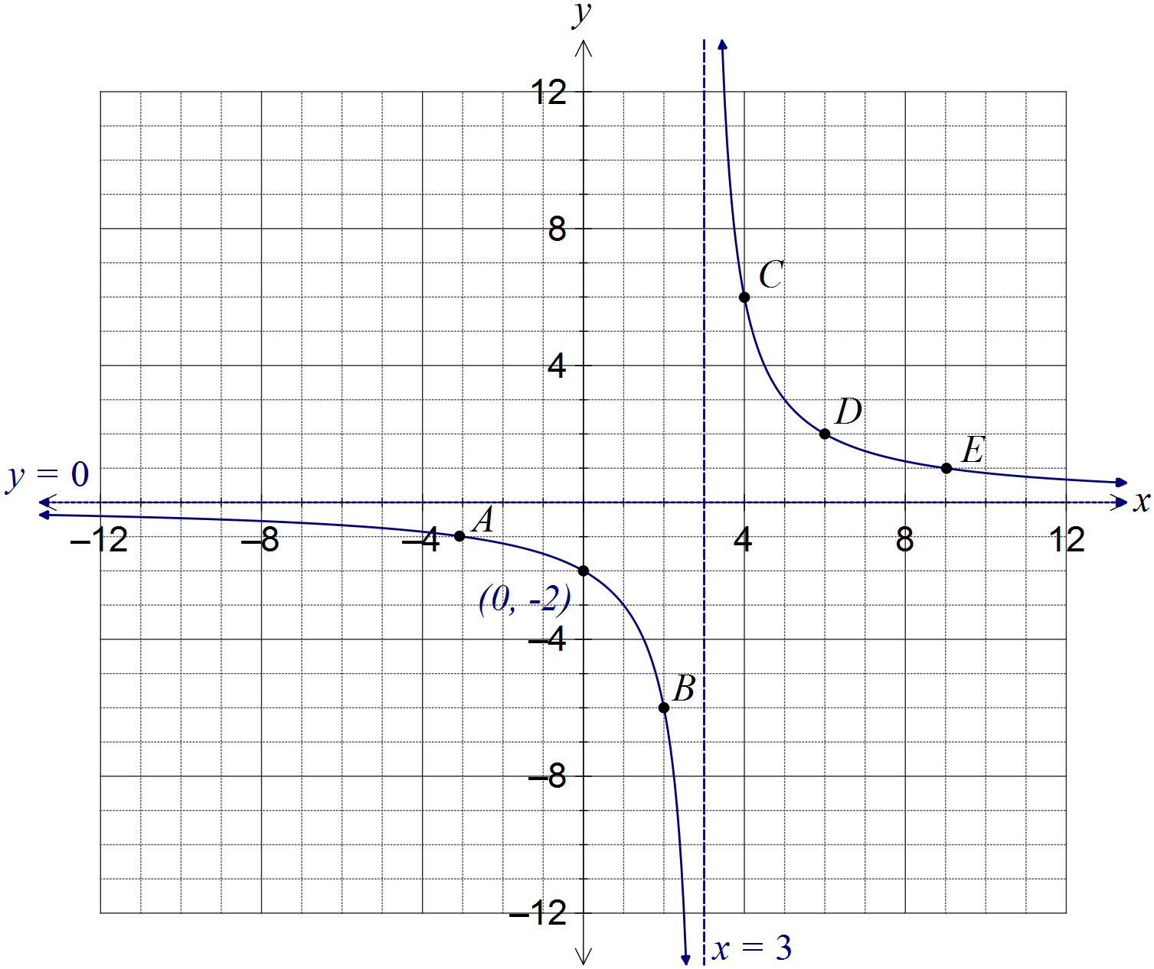
Solution
See graph
Specific behaviours
curves approach vertical asymptote, which is shown with equation
curves approach horizontal asymptote, without hooking upwards
coordinates of y-intercept shown
smooth curve passing through at least 3 of A, B, C, D or E

(c) The graph of is dilated vertically by a scale factor of 4 followed by a translation of three units to the right. Determine the coordinates of the y-intercept of the transformed graph. (2 marks)
Solution
Transforms the point (-3, -1) to (-3, -4) to (0, -4)
or
Specific behaviours
applies dilation
applies translation

Question 12 (8 marks)
(a) A 3.6 m long ladder first rests against a vertical wall BC, making an angle of 70° with the horizontal ground. The ladder is rotated in a vertical plane about E to rest against wall AD, reaching a point 2.6 m above the ground.

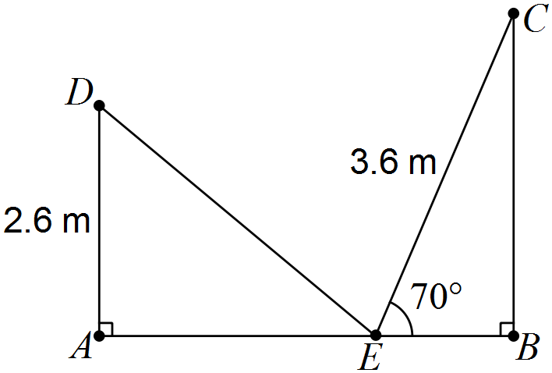

Showing use of trigonometry, determine

(i) the angle through which the ladder was rotated. (2 marks)
Solution
Specific behaviours
calculates angle in triangle
determines rotation angle

(ii) the distance AB. (2 marks)
Solution
Specific behaviours
determines AE
determines EB and adds to get AB

(iii) the distance DC. (2 marks)
Solution
Specific behaviours
uses cosine rule
determines length

(b) A thin metal plate in the shape of an equilateral triangle has an area of 330 cm. Determine the side length of the triangle. (2 marks)
Solution
Let side length be x. Then
Specific behaviours
uses area formula
determines length

Question 13 (8 marks)
(a) In a group of 47 people, 6 had surnames beginning with A, 5 had first names beginning with A and 38 had neither name beginning with A. Determine the probability that a randomly chosen person from the group

(i) has both names beginning with A. (2 marks)
Solution
Specific behaviours
uses probability rule
determines correct probability

(ii) only has a first name beginning with A. (1 mark)
Solution
Specific behaviours
determines probability

(iii) only has a surname beginning with A, given that either their first name or surname begins with A. (2 marks)
Solution
Specific behaviours
uses conditional probability
determines probability

(b) In the population as a whole, it was thought that 3% had surnames beginning with A, 4% had first names beginning with A and 0.15% had both names beginning with A. Estimate how many people in a group of 2000 will have neither name beginning with A.
(3 marks)
Solution
Specific behaviours
calculates union
calculates complement
calculates number

Question 14 (7 marks)
A function and a relation have been graphed on the axes below.

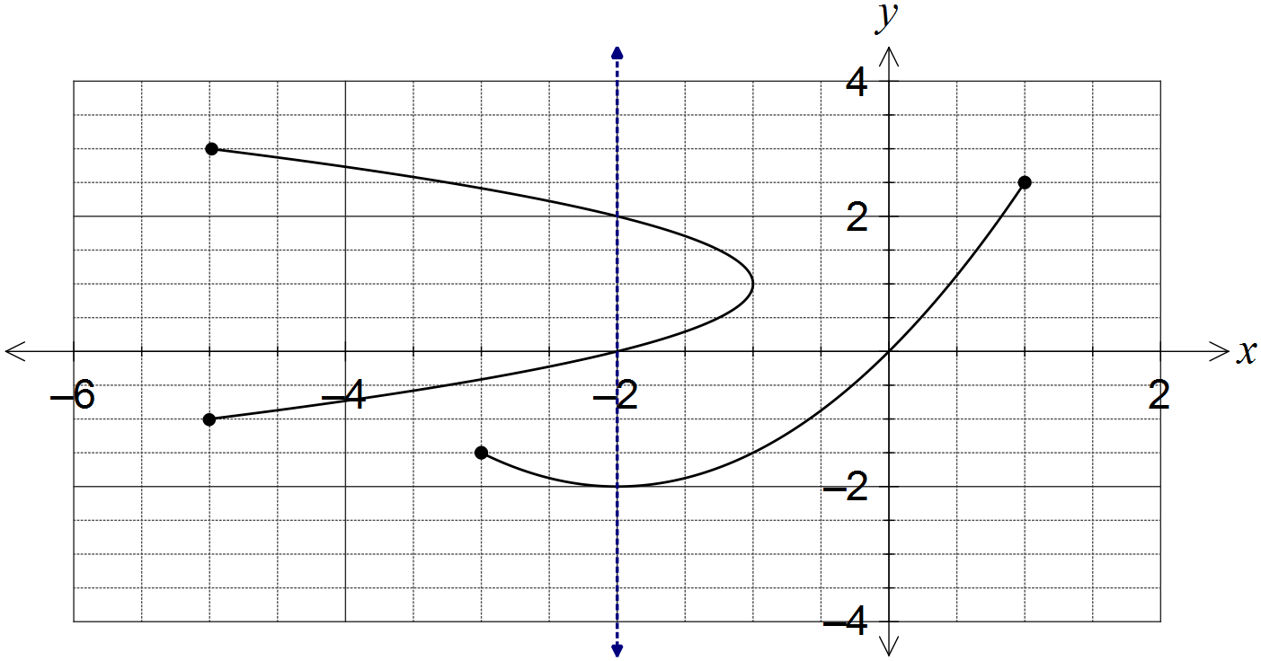

(a) Draw the line on the graph and explain how it can be used to identify the relation. (2 marks)
Solution
See line on graph.
Vertical line cuts the relation more than once, but the function just once.
Specific behaviours
draws vertical line
explains vertical line test

(b) State the domain and range of the function. (2 marks)
Solution
Specific behaviours
states domain
states range

(c) The relation can be expressed in the form . Determine the values of the constants a and b. (3 marks)
Solution
When .
Specific behaviours
selects suitable point from relation
determines a
determines b

Question 15 (9 marks)
A sensor was fitted to the tip of a blade on a wind turbine to measure the height, h metres, of the blade above the ground. The height was observed to vary according to the function , where is the time in seconds since measurements began.

(a) Determine the height of the blade tip above the ground when . (1 mark)
Solution
Specific behaviours
calculates height

(b) Sketch the graph of on the axes below for . (4 marks)

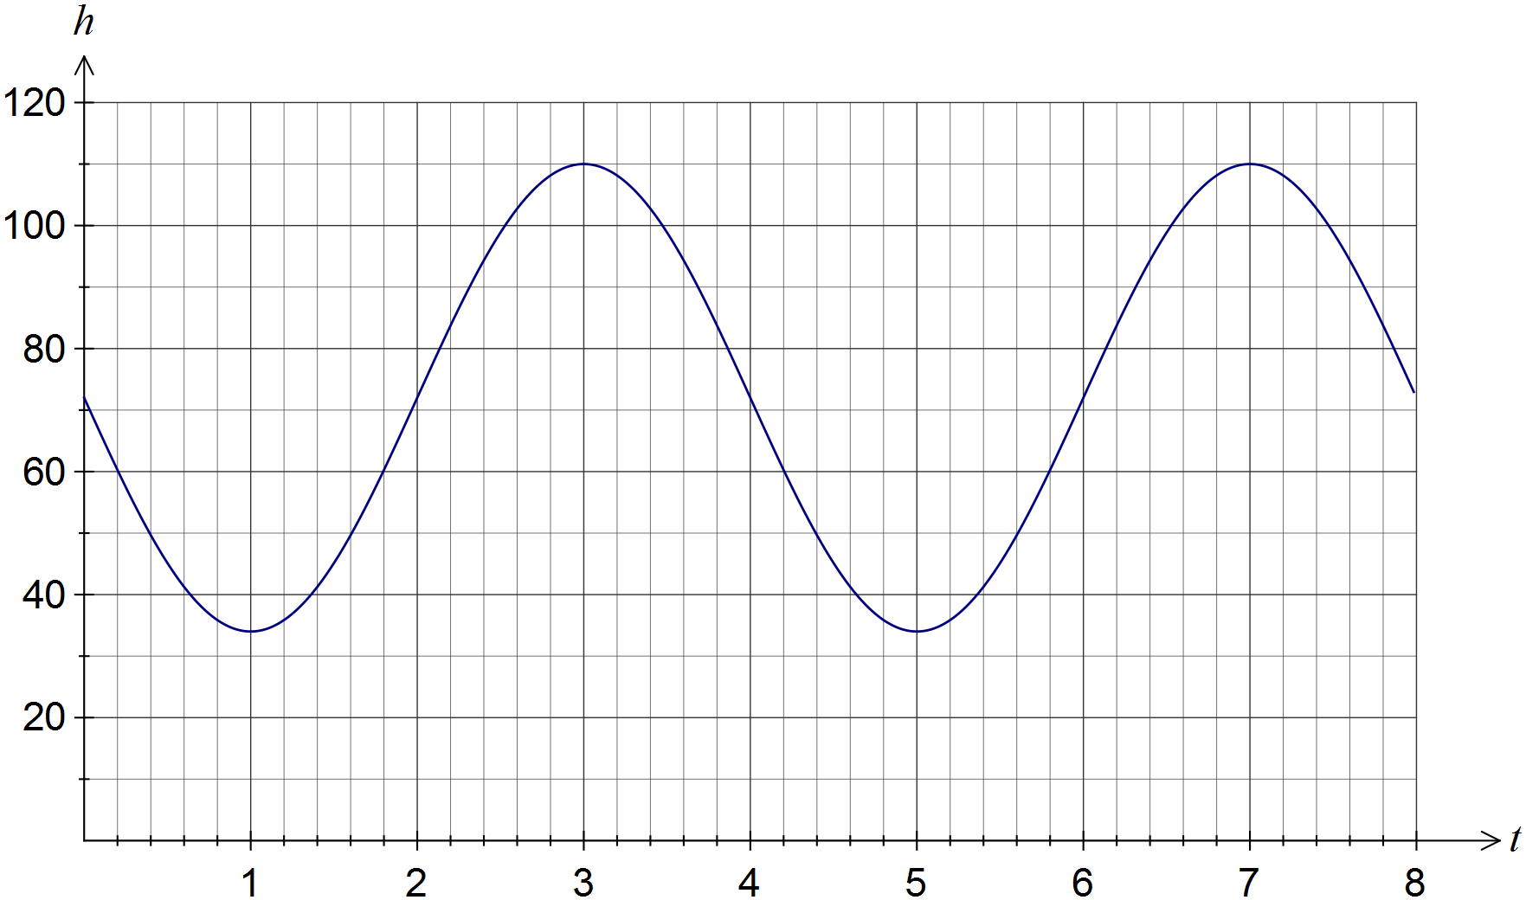
Solution
See graph
Specific behaviours
minimums at (1, 34) and (5, 34)
maximums at (3,110) and (7, 110)
smooth curve through above points, no abrupt 'corners'

(c) How long does the blade take to rotate once? (1 mark)
Solution
4 seconds
Specific behaviours
states time

(d) Assuming the blade continues to rotate in this manner, determine the percentage of time during which the blade tip is at least 90 m above the ground. (3 marks)
Solution
Specific behaviours
solves for height of 90 m
determines interval above 90
determines percentage

Question 16 (8 marks)
A selection of four representatives is to be made from eleven students, comprising six girls and five boys. Determine

(a) the number of ways in which this can be done. (2 marks)
Solution
Specific behaviours
uses combination
evaluates

(b) the number of selections that contain the same number of girls and boys. (2 marks)
Solution
Specific behaviours
uses multiplication of combinations
evaluates

(c) the probability that three of the representatives chosen are girls. (2 marks)
Solution
Specific behaviours
evaluates ways to choose three girls and one boy
expresses as probability

(d) the probability that more boys than girls are chosen. (2 marks)
Solution
Specific behaviours
evaluates ways to choose 3 or 4 boys
expresses as probability

Question 17 (9 marks)
(a) The diagram below shows the five graphs , , , and , where a, b, c and d are constants.

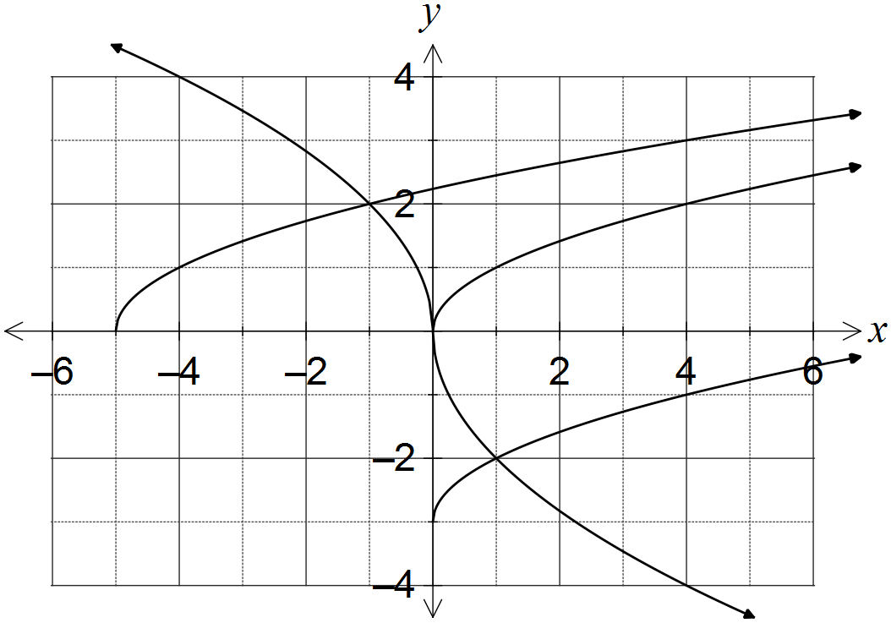

(i) Determine . (1 mark)
Solution
Specific behaviours
determines correct value

(ii) Determine the values of the constants a, b, c and d. (4 marks)
Solution
a is vertical translation:
b is horizontal translation:
c is vertical dilation and reflection in x-axis:
d is horizontal dilation and reflection in y-axis:
Specific behaviours
determines a
determines b
determines c
determines d

(b) Describe two transformations that will transform the graph of to:

(i) . (2 marks)
Solution
Translate original graph 1 unit right and 2 units downwards (in either order)
Specific behaviours
horizontal translation
vertical translation

(ii) . (2 marks)
Solution
Reflect in x-axis and dilate vertically by scale factor 5 (in either order)
Specific behaviours
reflection
dilation

Question 18 (8 marks)
The events and are such that and .

(a) Determine in each of the following cases.

(i) and are mutually exclusive. (1 mark)
Solution
Specific behaviours
determines probability

(ii) . (2 marks)
Solution
Specific behaviours
uses probability law
determines probability

(iii) . (2 marks)
Solution
Specific behaviours
determines
determines probability

(b) Are and independent in any of the above three cases? Justify each decision.
(3 marks)
Solution
(i) No -

(ii) Yes -

(iii) No -
Specific behaviours
correct response with reason for (i)
correct response with reason for (ii)
correct response with reason for (iii)

Question 19 (8 marks)
(a) Given that , where , show how to determine the exact value of

(i) . (2 marks)
Solution
Specific behaviours
uses right triangle to determine hypotenuse
states exact value

(ii) . (2 marks)
Solution
Specific behaviours
considers sign of cos in 2nd quadrant
states exact value

(iii) . (2 marks)
Solution
Specific behaviours
substitutes into double angle identity
simplifies correctly

(b) Determine the two smallest solutions to the equation for .
(2 marks)
Solution
Using CAS: , or:
Specific behaviours
determines one solution
determines both solutions

Question 20 (7 marks)
(a) Determine the exact area of a sector enclosed by an arc of length 42 cm in a circle of radius 12 cm. (2 marks)
Solution
Specific behaviours
calculates angle
calculates exact area

(b) In the diagram below, BC is a tangent to the circle with diameter AB and centre O.
Given that cm and cm, determine the shaded area. (5 marks)

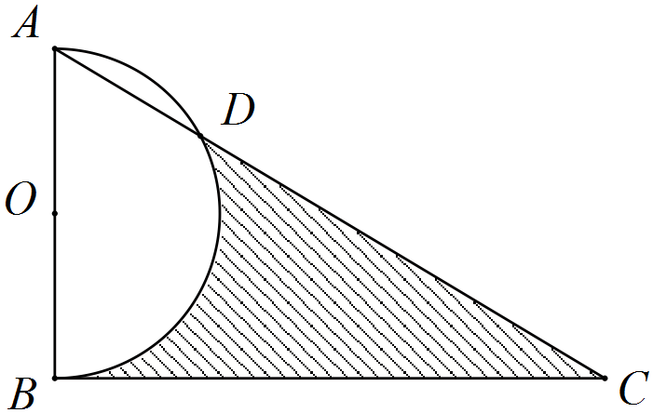

Solution
Specific behaviours
determines angle BAD
determines angle AOD
determines segment area
determines semicircle and triangle area
determines shaded area

Additional working space

Question number: _________

Additional working space

Question number: _________

Additional working space

Question number: _________

Additional working space

Question number: _________

© 2016 WA Exam Papers. Rossmoyne Senior High School has a non-exclusive licence to copy and communicate this paper for non-commercial, educational use within the school. No other copying, communication or use is permitted without the express written permission of WA Exam Papers.

